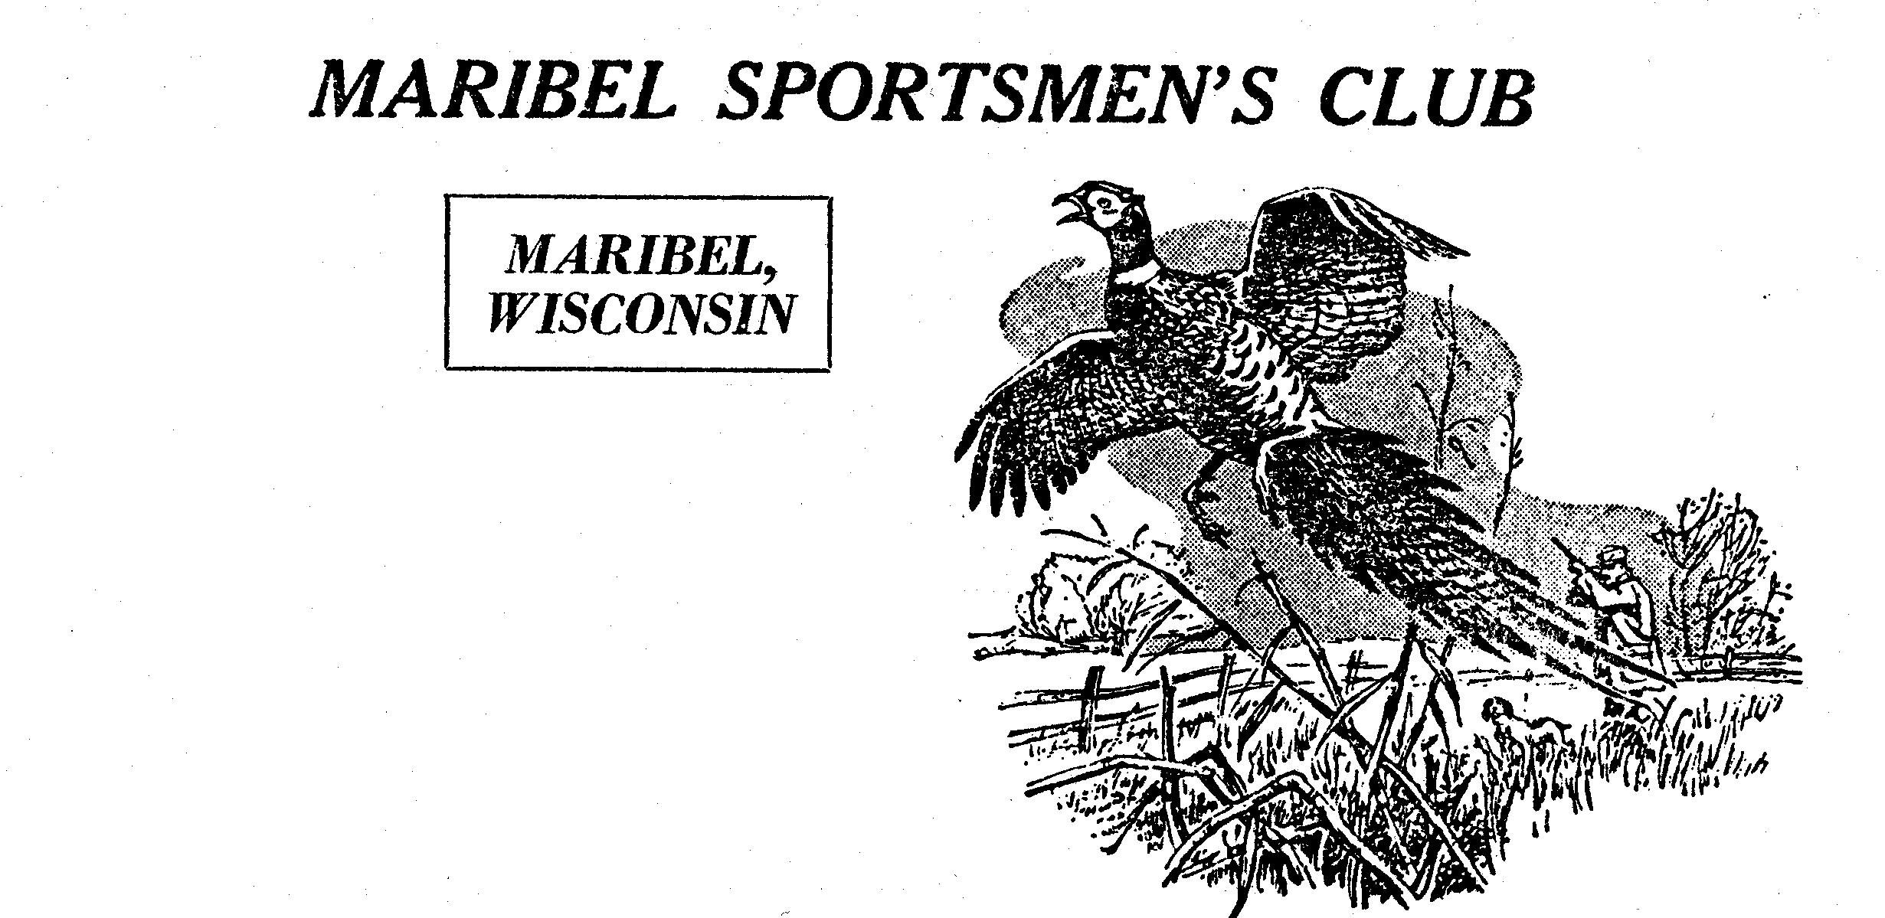
Maribel Sportsmen’s Club
P. O. Box 7

Maribel, WI 54227
March 14, 2023

Dear School Advisors,

Attached you will find an application for the Maribel Sportsmen’s Club annual $500 scholarship. Students that are going into any type of natural resources work, whether being fish, wildlife, forestry, parks, soils, water resources, etc… Applicants must have the completed application back to the Guidance Office or in the mail post marked no later than May 1st, 2024. Incomplete or late applications will not be considered. If there are any questions please feel free to call me. Forward all application forms to,

Bob Schuh
9204 County Road K
Whitelaw, WI 54247
Telephone (920) 682-3106
E-mail: bobschuh@lsol.net

